Faculty of Information Technology (FIT) – Ho Chi Minh City University of Science (HCMUS)
CS423 / CSC13003 – Software Testing (AI-augmented · 2026)
AI POLICY · TEMPLATES — 2026 v1.0

AI Audit Report — 5-section Template per Artifact
Mandatory appendix for every AI-assisted homework (HW#01–HW#06, and Seminar).
Adapted from Med Kharbach, PhD (2026) — AI Use Policy Templates for Higher Education. CC BY-NC-SA 4.0. This adaptation is prepared for FIT@HCMUS – CS423 / CSC15003 Software Testing course.

1. Student Information
Field | Value
Student name (printed): | Bùi Hữu Thịnh
Student ID: | 23127121
Class / Cohort: | 23KTPM2
Assignment ID (e.g., HW#00, HW#02): | HW#01
Assignment date: | 02/06/2026
AI tool(s) used: | ChatGPT
AI tool(s) used: | [x] Yes [ ] No

2. Instructions (read before filling)
- Add one row per AI-generated artifact (test case, script, checklist, OpenAPI spec, JMeter plan, etc.).
- Paste the verbatim prompt — DO NOT paraphrase.
- Paste the verbatim AI output (or include a labelled screenshot in the report).
- Tag the verdict: VALID / INVALID / INCOMPLETE.
- Reasoning must cite a course slide, ISTQB section, or technical RFC.
- Show the corrected artifact with the change highlighted.
- Sample rows are in italic — replace them before submission.

3. Audit Table — one row per artifact
(1) Prompt + Tool | (2) AI Output | (3) Verdict | (4) Reasoning (ISTQB) | (5) Student Fix
Tool: ChatGPT 5.5 (OpenAI)  Timestamp: 01/06/2026 13:35  Prompt:  " Create a mindmap of QA/QC career roles in 2026 including AI-related positions." | 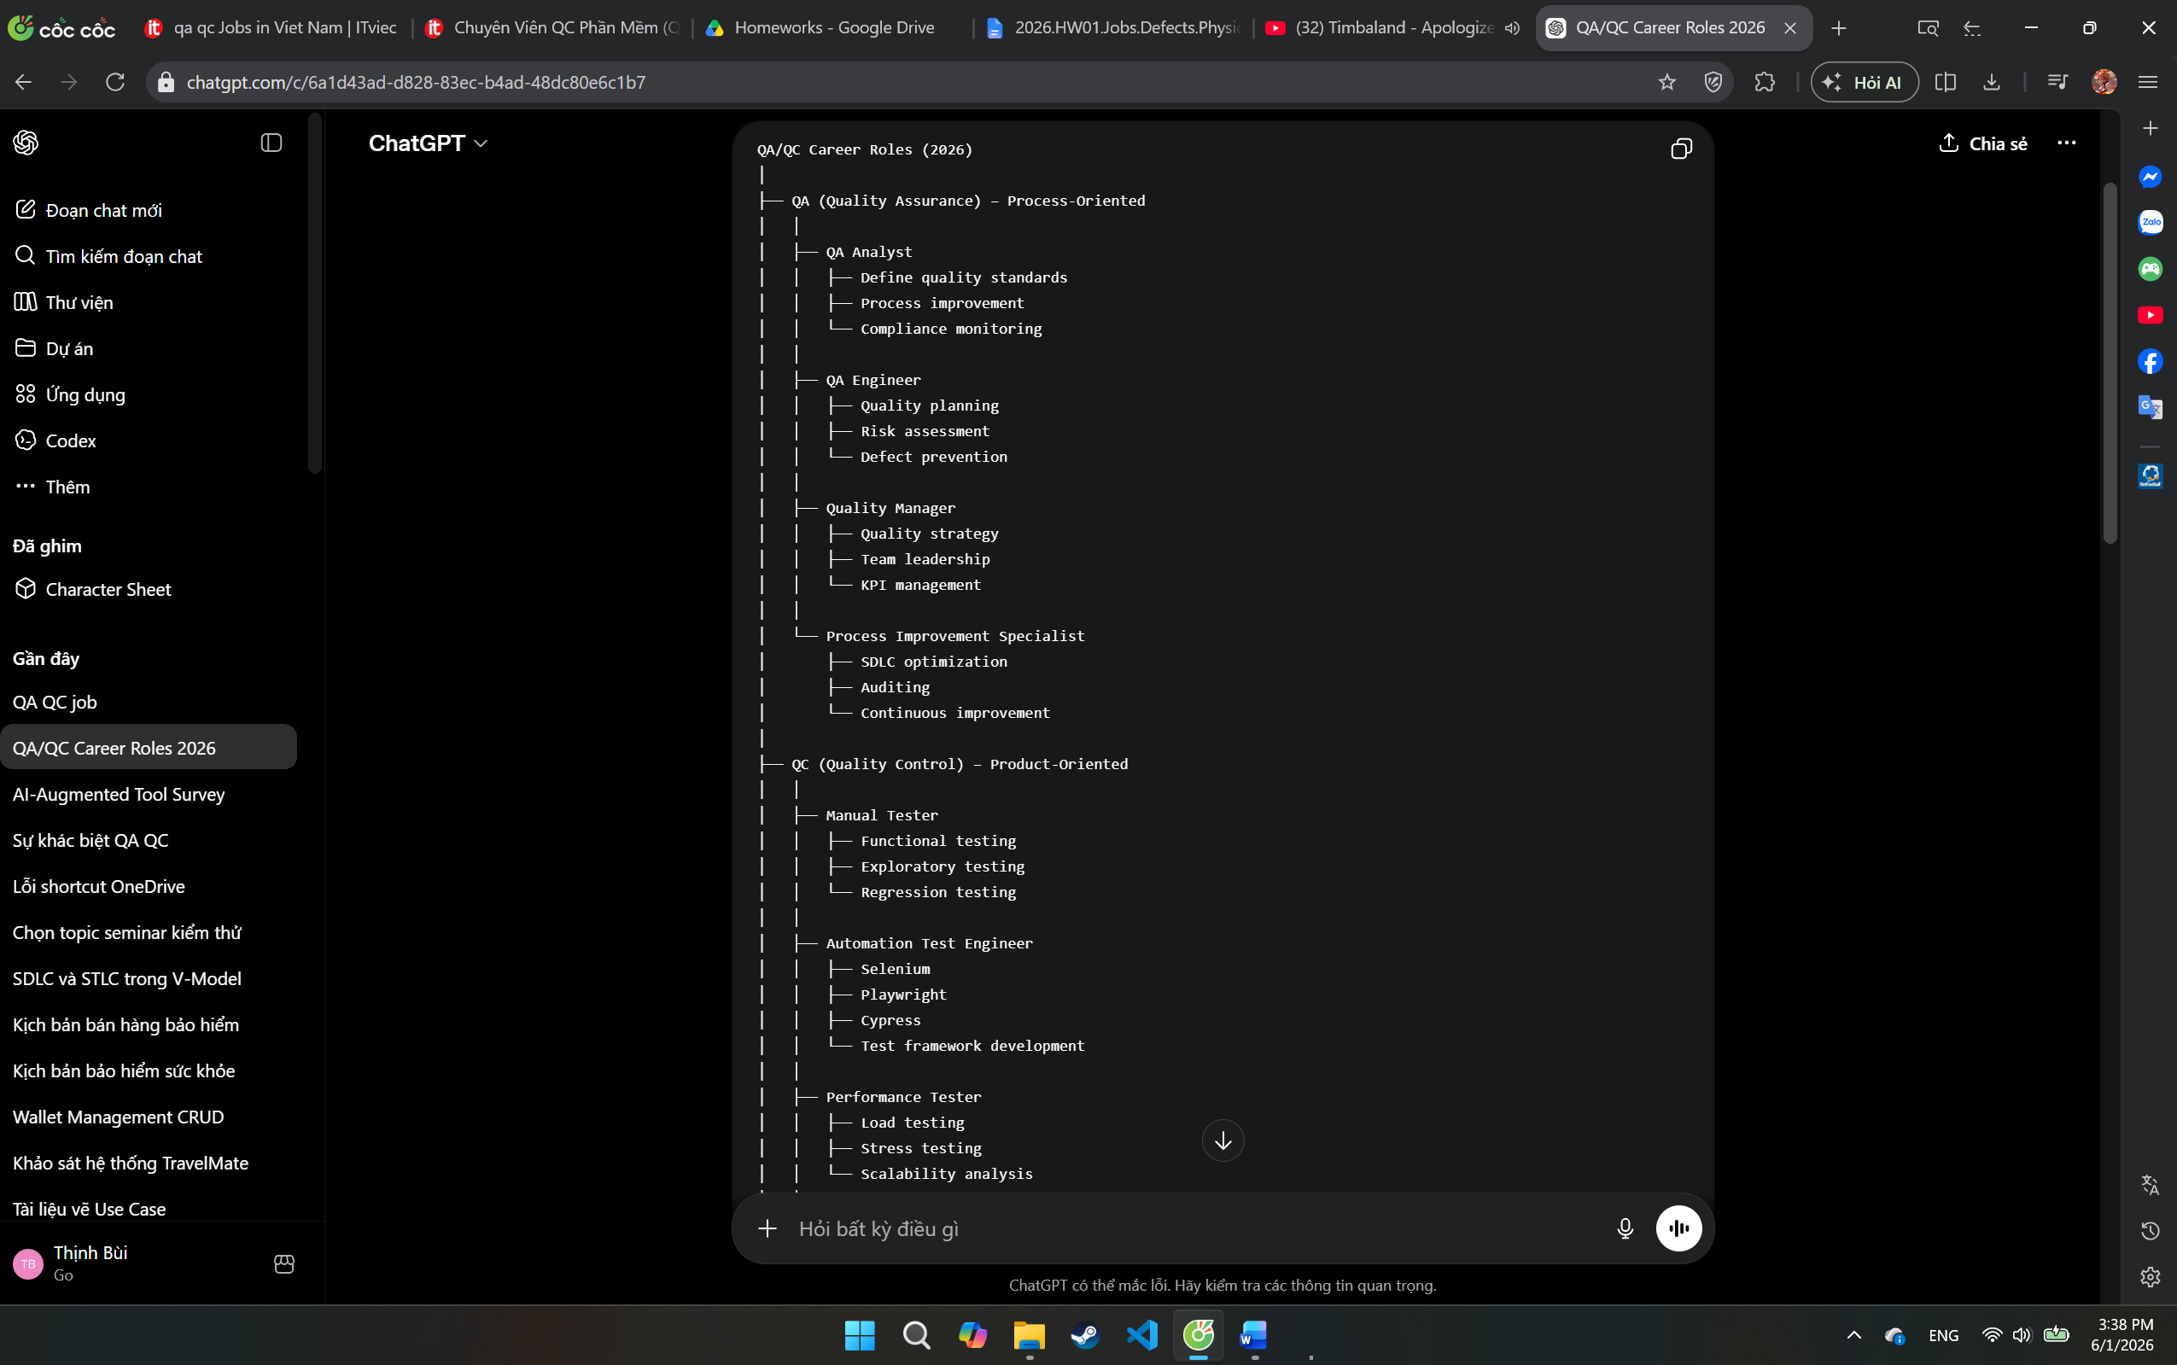  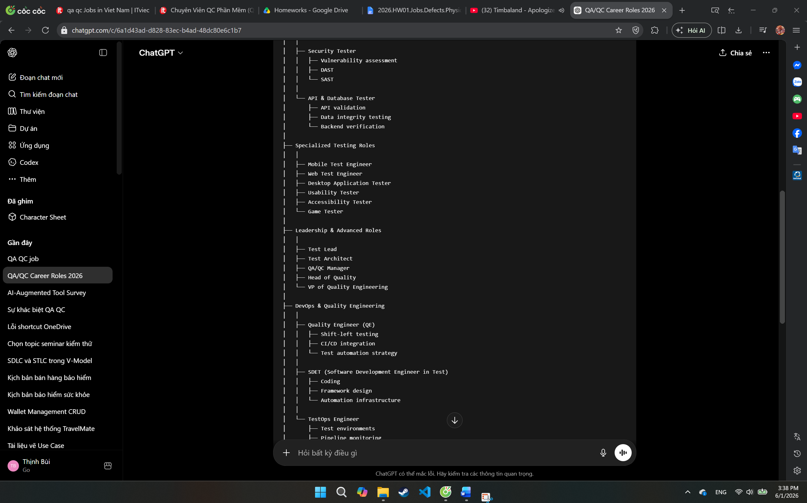  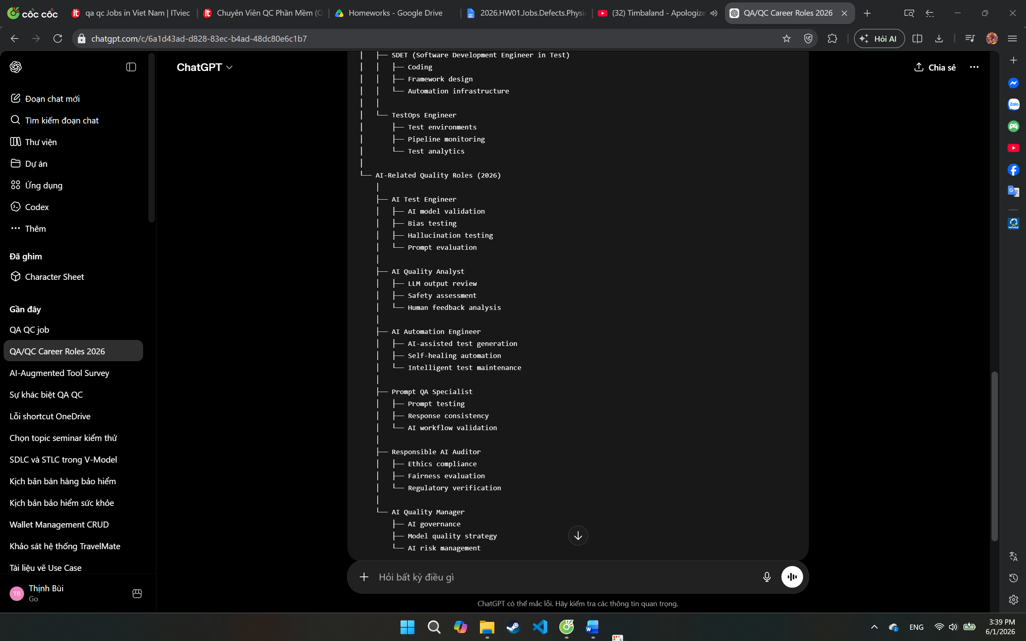 | INCOMPLETE | According to the ISTQB Certified Tester Foundation Level (CTFL) v4.0, Quality Assurance focuses on process-oriented activities intended to provide confidence that quality requirements will be fulfilled, while Testing is a quality control activity focused on evaluating work products and detecting defects.  The AI-generated mindmap groups many testing roles directly under QC without explaining that modern organizations often organize these roles under Quality Engineering (QE) rather than traditional QC. In addition, AI-specific roles such as Prompt QA Specialist and AI Quality Analyst are emerging industry titles rather than standardized QA/QC roles recognized by ISTQB.  Reference:  • ISTQB CTFL v4.0, Chapter 1.1 – What is Testing?  • ISTQB CTFL v4.0, Section 1.2 – Testing and Quality Assurance  • Course Slides: QA vs QC vs Testing | • Added Quality Engineering as the overarching discipline.  • Reorganized testing roles under Testing/Quality Engineering.  • Marked AI-related roles as emerging industry positions rather than standardized ISTQB roles.  Changes Highlighted:  • Added Quality Engineering (QE) as the top-level discipline.  • Moved testing roles from a strict QC category into Testing / Quality Control Activities.  • Clarified that AI positions are emerging industry roles and not official ISTQB role definitions
Tool: ChatGPT 5.5 (OpenAI)  Timestamp: 01/06/2026 14:00  Prompt:  " List 20 software defects and their source links publicized between 2022 and 2026." | 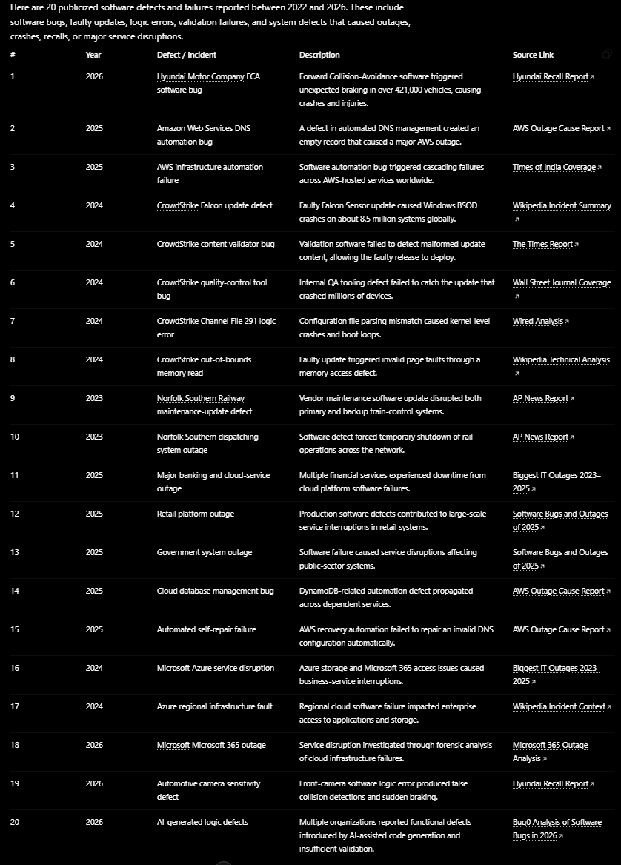 | INCOMPLETE | - The AI provided 20 entries and included source links.  - However, several entries are duplicates of the same incident (multiple CrowdStrike rows and multiple AWS rows describing the same root defect).  - Some entries are outage summaries rather than clearly identified software defects.  - The output lacks defect classification, severity, root cause, and verification status.  ISTQB-Based Reasoning  According to ISTQB Certified Tester Foundation Level defect reporting should provide clear, unique, and traceable defect information. A defect list should avoid duplicate reporting and should distinguish between:  - Defect  - Failure  - Incident  - Root cause  Several entries represent consequences of the same defect rather than separate defects, reducing defect traceability and accuracy. | - Merge into CrowdStrike outage root cause  - Keep as technical root cause  - Merge if same defect chain  - Merge under AWS outage root cause  Changes Highlighted:  - Removed duplicate defect records.  - Added defect category.  - Added root cause.  - Added severity level.  - Ensured each row represents one unique defect rather than multiple symptoms of the same incident.
Tool: ChatGPT 5.5 (OpenAI)  Timestamp: 01/06/2026 14:25  Prompt:  " List 5 software defects related to AI/LLM (hallucination, prompt injection, bias) and provide source links" | Mata v. Avianca – ChatGPT generated fake legal cases that were submitted to court.  Source: https://en.wikipedia.org/wiki/Mata_v._Avianca%2C_Inc.  Air Canada Chatbot Case – Chatbot provided incorrect bereavement fare information.  Source: https://aibusiness.com/nlp/air-canada-held-responsible-for-chatbot-s-hallucinations  Microsoft Bing Chat – Prompt injection exposed hidden system prompts.  Source: https://arstechnica.com/information-technology/2023/02/ai-powered-bing-chat-spills-its-secrets-via-prompt-injection-attack  Google Gemini – Historically inaccurate image generation due to bias mitigation issues.  Source: https://www.reuters.com/technology/google-pause-gemini-ai-models-image-generation-people-2024-02-22  OpenAI Defamation Case – ChatGPT falsely accused an individual of criminal activity.  Source: https://www.globallegalinsights.com/news/openai-wins-ai-hallucination-defamation-lawsuit | INCOMPLETE | According to ISTQB CTFL 4.0 Section 1.4 (Testing and Quality Assurance), test evidence should be verifiable and reproducible.  The AI correctly identified several real-world examples of hallucination and prompt injection defects. However, it did not classify the defects consistently using standard defect taxonomy and omitted key information such as defect severity, impact, and verification status.  Additionally, one source (Global Legal Insights article) reports litigation outcomes rather than documenting a confirmed software defect, making the defect classification ambiguous.  Therefore, the answer is useful but incomplete from a software quality perspective. | - Replace with a documented software defect having a verified root cause.  - Add Severity (Critical / Major / Minor)  - Add Business Impact and User Impact columns.  - Categorize as Hallucination / Prompt Injection / Bias.  Changes Highlighted:  - Added defect category.  - Added severity classification.  - Added impact assessment.  - Replaced ambiguous case with a documented software defect.
Tool: ChatGPT 5.5 (OpenAI)  Timestamp: 01/06/2026 21:15  Prompt:  "List 12 test cases (Objective / Input / Steps / Expected / Actual / Verdict) of SENKO fan TC1886" | The AI generated test cases covering:  - Verify fan powers on  - Verify Speed Level 1 operation  - Verify Speed Level 2 operation  - Verify Speed Level 3 operation  - Verify OFF function  - Verify oscillation ON  - Verify oscillation OFF  - Verify fan head tilt adjustment  - Verify stability during continuous operation  - Verify power recovery behavior  - Verify protective grille safety  - Verify airflow coverage  The AI focused mainly on normal operating conditions and standard functional testing. | INCOMPLETE | According to ISTQB principles, effective testing should include both normal and abnormal scenarios. Physical devices are subject to environmental conditions, state transitions, and mechanical constraints that may reveal defects not observable during normal operation.  The AI-generated test suite lacked edge-case coverage and therefore could not provide sufficient confidence in product reliability. | Added three edge cases not identified by AI:  - EC01 – Rapid Speed Switching  - Change speed continuously: 1→2→3→1.  - Verify motor stability and noise.  - EC02 – Power Loss During Oscillation  - Disconnect power while oscillation is active.  - Verify recovery after power restoration.  - EC03 – Temporary Oscillation Resistance  - Apply light resistance to oscillating fan head.  - Verify normal operation after resistance is removed.  Change Speed Level 1 operation to Speed Level 3 operation and vice versa.  Changes Highlighted:  - Added 3 edge cases. Adjust TC02 and TC04.

4. Summary of AI Accuracy
Aggregate the verdicts from Section 3 and complete the table below.
Metric | Count | Percentage
Total AI-generated artifacts audited | 4 | 100%
VALID (correct, accepted as-is) | 0 | 0%
INVALID (wrong; rejected) | 0 | 0%
INCOMPLETE (acceptable after edits) | 4 | 100%

5. Conclusion — When should AI be used (or not)?
Write 80–150 words describing patterns you observed. Where did AI shine? Where did AI fail? What is your recommendation for using AI in this kind of work in the future?
During this homework, I observed that AI performed well at generating initial ideas, summarizing information, and creating baseline test cases quickly. It was particularly useful for identifying software defects, organizing data into structured formats, and producing standard functional test cases. However, AI often missed important details such as edge cases, root-cause distinctions, and context-specific scenarios. For example, it focused on normal fan operations but failed to identify power-interruption and mechanical-resistance test cases. In some software-defect analyses, AI also provided overly generic explanations that required verification against official sources. My recommendation is to use AI as a productivity and research assistant rather than a final decision-maker. Future users should validate AI-generated content, cross-check sources, and apply human judgment to identify missing risks, edge cases, and real-world constraints.

6. Mandatory Disclosure (paste verbatim)
This report was initially generated with the assistance of ChatGPT 5.5. I reviewed and modified the QA/QC job market analysis, verified all software defect sources, and added severity assessments, consequences, solutions, and AI hallucination/bias analyses for each defect. For Requirement 3, the initial test cases for the Senko TC1886 wall fan were generated by ChatGPT; however, I reviewed and refined the test suite, added three edge cases (EC01 – Rapid Speed Switching, EC02 – Power Loss During Oscillation, and EC03 – Temporary Oscillation Resistance), and executed the selected test cases on the real device.
The device information, device photo with student ID card, test execution results, video recordings, self-assessment, and final conclusions were completed and verified by me. The AI-generated outputs were reviewed, corrected where necessary, and supplemented with manual analysis and fact-checking using official sources.
The detailed AI Audit Report is attached as Appendix A. I confirm that I did not use AI to generate any artifact listed in the prohibited category, including the device photo, execution videos, and other anti-cheat evidence required by the assignment.

Signature
Student name (printed): | Bùi Hữu Thịnh
Student ID: | 23127121
Class / Cohort: | 23KTPM2
Course: | CS423 / CSC13003 – Software Testing
Instructor: | Lâm Quang Vũ
Date: | 02/06/2026
Signature: | Thinh

References
- Kharbach, M. (2026). AI Use Policy Templates for Higher Education. CC BY-NC-SA 4.0.
- ISTQB Foundation Level Syllabus (latest version).
- Hardman, P. (2025). A Post-AI Learning Taxonomy.
- Fuster Rabella, M. (2025). OECD Education Working Paper No. 338.
- Perkins, M., Roe, J., & Furze, L. (2025). AI Assessment Scale.
- Anthropic (2025). Building reliable AI test agents — engineering blog.
- DeepEval & Promptfoo documentation — testing frameworks for LLM systems.

